**IDEA 1** [**https://www.figma.com/file/44kUgf6YH0l4MFO3cXYouG/idea1?node-id=0%3A1**](https://www.figma.com/file/44kUgf6YH0l4MFO3cXYouG/idea1?node-id=0%3A1)

**Concepts:**

* **Hidden Meanings**
* **Deeper Insight**

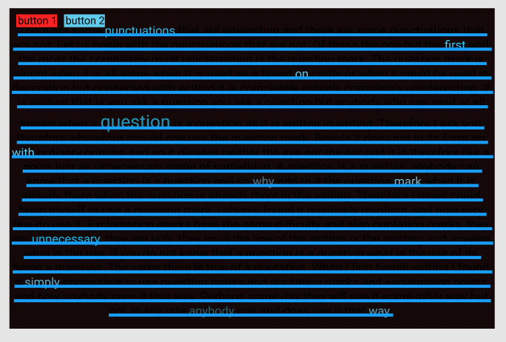

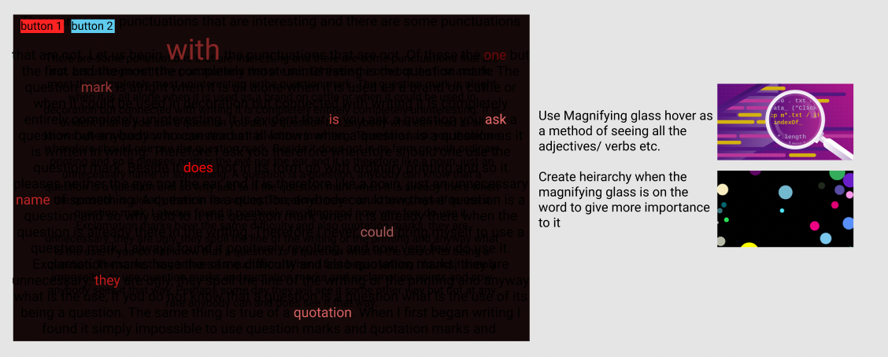

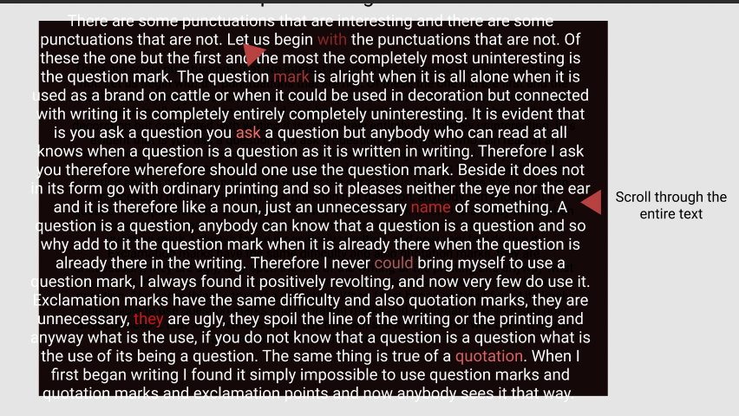

**IDEA 2** [**https://www.figma.com/file/uImreSFf4HTNDFacM8zaLk/idea2?node-id=0%3A1**](https://www.figma.com/file/uImreSFf4HTNDFacM8zaLk/idea2?node-id=0%3A1)

**Concepts:**

* **Flowing & Curious Nature**

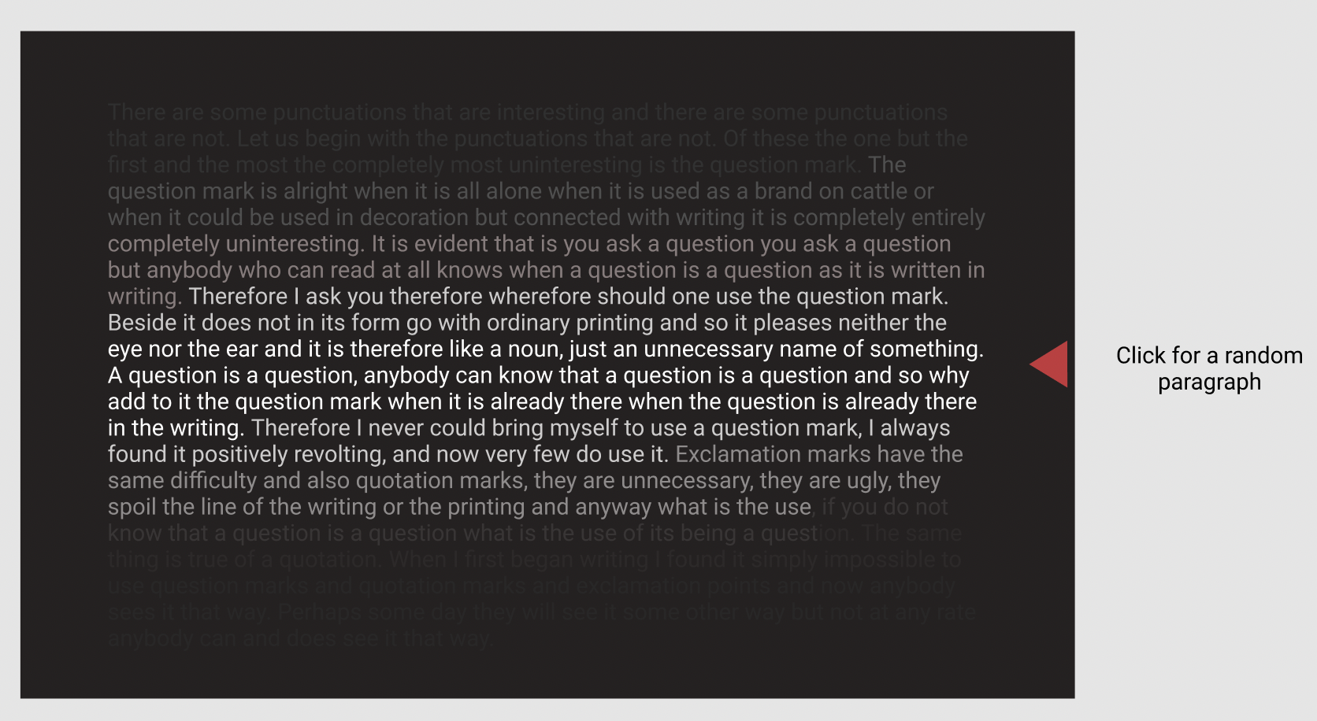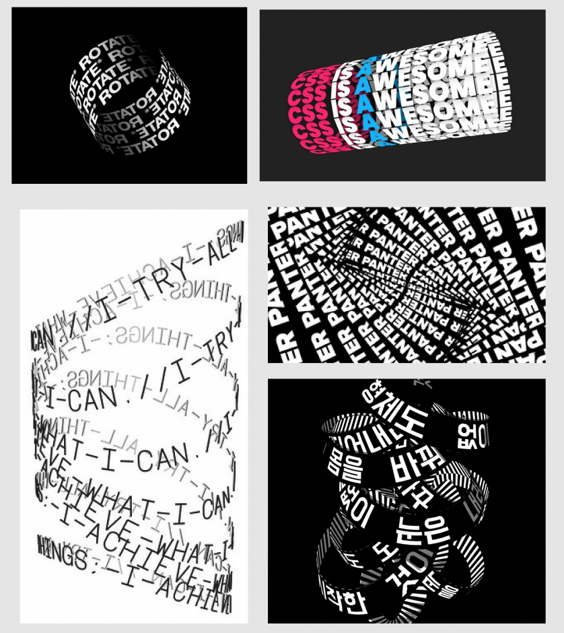

**IDEA 3** [**https://www.figma.com/file/pEm4nD8Vl1EigWdIBxdhUV/idea3?node-id=0%3A1**](https://www.figma.com/file/pEm4nD8Vl1EigWdIBxdhUV/idea3?node-id=0%3A1)

**Concepts:**

* **Hidden Meanings**
* **Curious Nature**

